Appendix 3. Cause and Effect with DirecTV

This example uses the DirecTV commercial “Don’t Chase Imaginary Butterflies,” available on YouTube. Use this chart to preteach vocabulary and help students understand the commercial.

DirecTV: Don't Chase Imaginary Butterflies Into Something Illegal
have cable TV | 
cable's on the fritz | 
one thing leads to another | 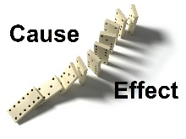
chasing imaginary butterflies | 
doing something illegal | 